
Assessment

Course -Btech CSE Robotics and AI
Discipline - SOET
Program - Nand -to-Tetris
Name - Ajitesh Singh Gusain
Faculty – Dr. Ayyala kishore Ajay Kumar
Sem - 3
Course code - ETCCNT301

Lab 1 - Question 2: Implementation of XOR, Mux (2-Way & 4-Way), and DMux Chips
1. Overview
In this section, we implement higher-level combinatorial logic chips using elementary logic gates (Not, And, Or, Mux). These chips form the foundation of control flow and routing in computer architectures.
2. Detailed Chip Implementations
A. Exclusive OR Gate Xor
- Explanation: An XOR (Exclusive OR) gate outputs 1 when the inputs are different, and 0 when they are identical. It is constructed using two AND gates, two NOT gates, and one OR gate to compute $\left(a⋅\overline{b}\right)+\left(\overline{a}⋅b\right)$.
- Boolean Expression: $\text{out}=a⊕b=\left(a⋅\overline{b}\right)+\left(\overline{a}⋅b\right)$
- Truth Table:
a | b | out | Explanation
0 | 0 | 0 | Inputs same
0 | 1 | 1 | Inputs different
1 | 0 | 1 | Inputs different
1 | 1 | 0 | Inputs same

HDL Code:
Code snippet
CHIP Xor {
IN a, b;
OUT out;

PARTS:
Not(in=a, out=notA);
Not(in=b, out=notB);
And(a=a, b=notB, out=term1);
And(a=notA, b=b, out=term2);
Or(a=term1, b=term2, out=out);
}

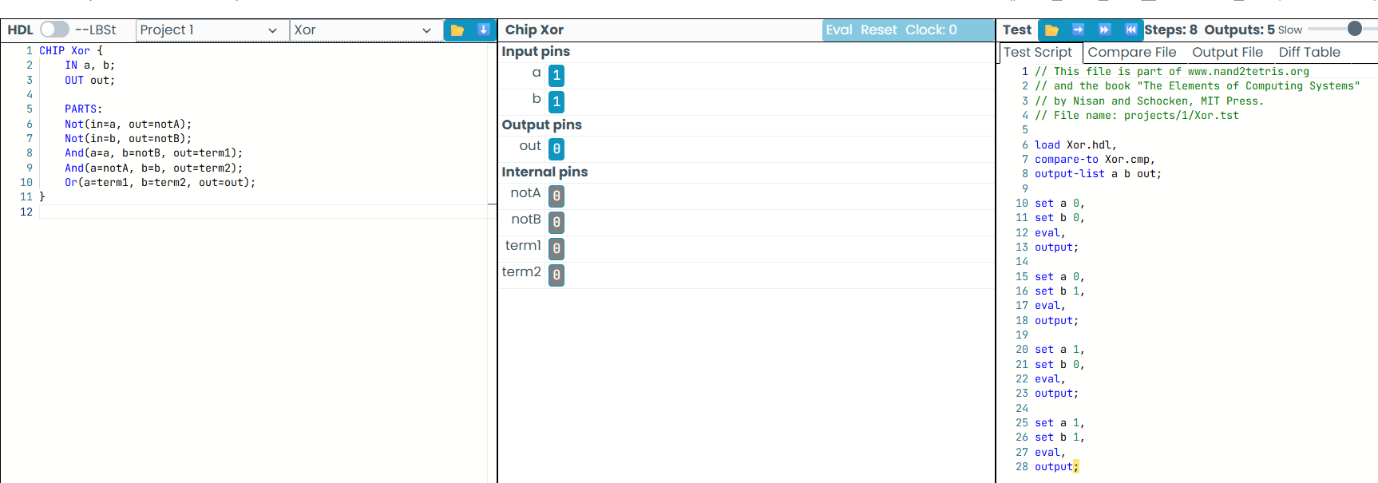

B. 2-Way Multiplexer
- Explanation: A Multiplexer acts as a digital switch. It routes one of two input signals (a or b) to out depending on the selector signal (sel). If sel = 0, it outputs a; if sel = 1, it outputs b.
- Boolean Expression: $\text{out}=\left(a⋅\overline{sel}\right)+\left(b⋅sel\right)$
- Truth Table:
a | b | sel | out | Selected Output
0 | 0 | 0 | 0 | a (0)
0 | 1 | 0 | 0 | a (0)
1 | 0 | 0 | 1 | a (1)
1 | 1 | 0 | 1 | a (1)
0 | 0 | 1 | 0 | b (0)
0 | 1 | 1 | 1 | b (1)
1 | 0 | 1 | 0 | b (0)
1 | 1 | 1 | 1 | b (1)
- HDL Code:
Code snippet
CHIP Mux {
IN a, b, sel;
OUT out;

PARTS:
Not(in=sel, out=notSel);
And(a=a, b=notSel, out=aSelected);
And(a=b, b=sel, out=bSelected);
Or(a=aSelected, b=bSelected, out=out);
}
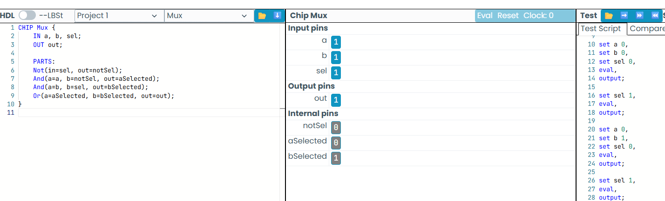

C. Demultiplexer DMux
- Explanation: A Demultiplexer performs the reverse operation of a Multiplexer. It takes a single input signal in and routes it to one of two outputs (a or b) based on the selector sel. The unselected output is set to 0.
- Boolean Expressions: $a=in⋅\overline{sel}, b=in⋅sel$
- Truth Table:
in | sel | a | b | Routed Output
0 | 0 | 0 | 0 | Both 0
0 | 1 | 0 | 0 | Both 0
1 | 0 | 1 | 0 | Signal to a
1 | 1 | 0 | 1 | Signal to b
- HDL Code:
Code snippet
CHIP DMux {
IN in, sel;
OUT a, b;

PARTS:
Not(in=sel, out=notSel);
And(a=in, b=notSel, out=a);
And(a=in, b=sel, out=b);
}
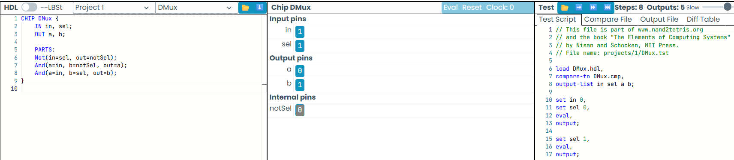

D. 4-Way 16-Bit Multiplexer Mux4Way16
- Explanation: This chip selects one 16-bit input bus out of four (a, b, c, or d) using a 2-bit selector control sel[2]. It uses a tree structure composed of three built-in Mux16 gates: two first-stage Muxes pick between (a, b) and (c, d) using sel[0], and the final Mux selects between those results using sel[1].
- Selection Logic Table:
sel[1] | sel[0] | Selected 16-Bit Output Bus
0 | 0 | a
0 | 1 | b
1 | 0 | c
1 | 1 | d
- HDL Code:
Code snippet
CHIP Mux4Way16 {
IN a[16], b[16], c[16], d[16], sel[2];
OUT out[16];

PARTS:
Mux16(a=a, b=b, sel=sel[0], out=muxAB);
Mux16(a=c, b=d, sel=sel[0], out=muxCD);
Mux16(a=muxAB, b=muxCD, sel=sel[1], out=out);}
